- What is the command to change directory and how to move one directory back?
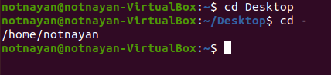
- cd to change directory
- cd – to move one directory back

- What is the command to make directory named IPHONE and IPAD and remove the directory named IPAD?
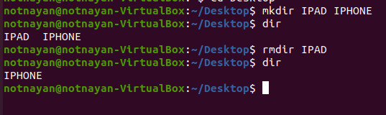

- Make a directory name TextDocuments in the desktop and make 3 text files: textfile1.txt, textfile2.txt and textfile3.txt inside the TextDocument.

- Remove the directory TextDocuments and contents within it.
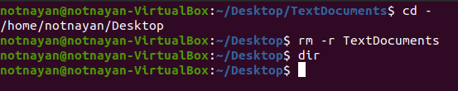

- What is the command to list all the invisible files and to display the directories in detail?
  - ls –a
  - ls –l
  - ls -al

- How to remove the commands from screen without closing the terminal?
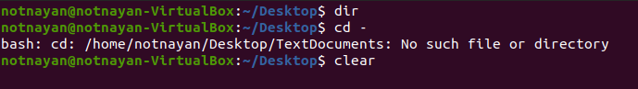
clear

- Which command is used to find out the path of the current working directory (folder) you’re in?
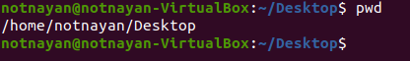
pwd
- What is the command to check which directory are you currently working on?

pwd

- What is the difference between?
  - cd ..
To navigate to previous directory
  - cd
To go to home directory
  - cd –
It contains the old pwd value

- Create a file name name.txt on Desktop and add text “Hello, my name is John” into the file.
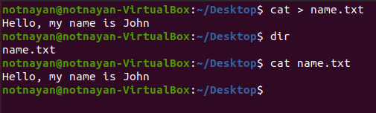

- Copy new.txt from the current directory to a Document directory.
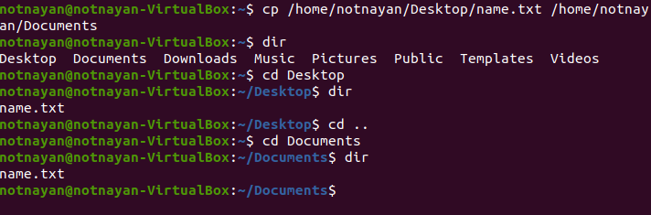

- Compress the file “name.txt” into a zip archive.
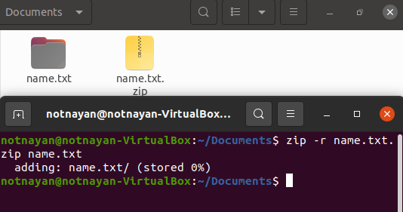

- df is used to get the report of disk space uses on the system. The results shown is KBs. What if I want to see the report in megabytes?
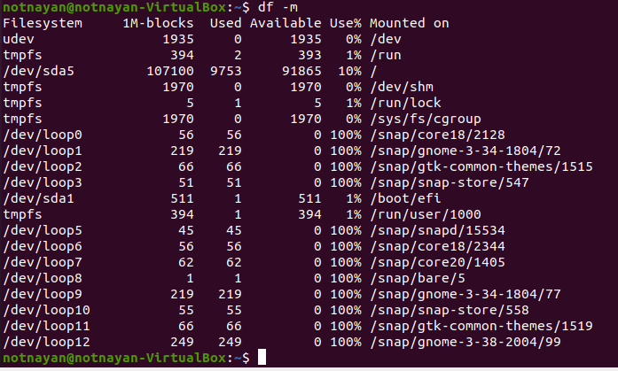
df -m — to display information of file system usage in MB.

- What is the command to move file KAT.txt from directory Pictures to directory Videos if the full path of Pictures directory is /home/user/Pictures?
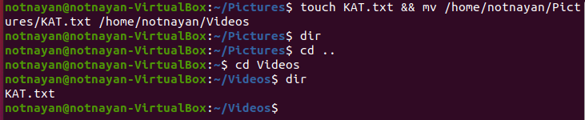
mv /home/notnayan/Pictures/KAT.txt /home/notnayan/Videos

